Report of How the Cyber Supply Chain Influences the Approach That Project Manager Uses to Manage Cybersecurity Risks

FIT 5057 Assignment 1

Abstract
This report will discuss how project managers manage cyber supply chain risks. We will talk about many aspects about cyber supply chain management, like the definition and the type of the risks. We also picked a main topic – vendor – to stress the approach and importance of cyber supply chain risks management. Some frameworks for cyber supply chain risk management are also discussed in this report. Finally, we compared the commons and differences of the approach chosen by Australian Cyber Security Centre, (2020) and Presley & Landry’s, (2016).
Introduction
Supply chain is a structure that ensures a business or company to effectively conduct business activities. Nowadays, besides the physical supply chain, the cyber supply chain has gradually become a new structure to handle a huge IT project. The security issue of cyber supply chain also arises at this moment. It is particularly important that the project manager should always assess the security of their cyber supply chain, and try to reduce the risks it may bring in.
In this report, we will define what a cyber supply chain and what C-SCRM should we choose to manage the cyber supply chain in a better way.
Body
  - Cyber Supply Chain Management(CSCM)
    - Definition
A conventional or physical supply chain (SC) is controlled by the dynamic of manufactured items, budget, and information (Peck, 2006). Meanwhile, a cyber supply chain(CSC) is defined as an interconnected set of IT infrastructure and approaches that are used to link, create, send, and receive data in the cyber world (Smith et al., 2007). Added by Ghadge et al. (2019), CSC also brings new risks that are not directly related to real products or locations.
Thus, we should always care about cyber supply chain risk management. The relation between supply chain risk management (SCRM) and cyber supply chain risk management (C-SCRM) is similar to SC and CSC.
SCRM is defined as the strategy and management to handle daily potential risks besides the supply chain based on successive risk assessment (Heckmann, Comes, &amp; Nickel, 2015); whereas Boyens (2020) defined C-SCRM as “the process of identifying, assessing, and mitigating the risks associated with the distributed and interconnected nature of IT/OT product and service supply chains.”
    - Cyber Supply Chain Risks That Affect Organisations
According to Ghadge et al. (2019), there are four types of cyber risks that affect organisations: Physical threats, Breakdown, Indirect & Direct attacks, and Insider threats.
Physical threats are the intentional and functioning damage or snatch of physical infrastructure. For example, some cities may suffer flooding every year, which will cause damage to their IT infrastructure. Or some espionages break or steal the physical storage device of the organisations.
The breakdown is the crash of a system or the interruption of resources, which is not intended to happen. For instance, unexpected powering off will cause the system to shut down and data loss.
There are two types of deliberate assaults, which are indirect attacks and direct attacks. Indirect attacks include attacks like denial-of-service and sniffing; whereas direct attacks contain virus attacks or attacks that cause damage to the system or resources.
Insider threats are usually caused by staffs inside the organisation. It can be intentional or non-intentional. Given an example, recently, Twitter was hacked by a hacker who sent spoofing email to Twitter employees to obtain access to the internetwork of Twitter.
  - An Approach to Vendors Risk Management in CSCM
As defined by ACSC(2020), a vendor is usually the organisation that provides a product or service to the customer. A high-risk vendor refers to any supplier that has an essential affect to risk the security of your system, based on the nature of their products or services.
Thus, the organisation need to take measures on Vendors Risk Management(VRM).
ACSC(2020) states that there are four aspects to manage supply chain risks: “1) know your system, 2) understand your supply chain risk, 3) manage our supply chain risk, and 4) monitor your supply chain and controls.”
Similarly, we can develop an approach to VRM.
- Know your vendors.
You must know your vendors and the fields related to them. It is important to know where your vendors come from because there might be some risks behind the policy of their countries.
Know the state of your vendors as well. You need to understand what problems your vendors are facing to assess the ability of your vendors to offer their products.
Know what other countries affect your vendor. For example, if your vendor has some infrastructures in other countries, will their products be sanctioned by that country?
Know the degree of your vendors’ cybersecurity risk management. Make sure your vendors have a relatively secure working environment to maintain your demands.
- Understand the risks that may be brought by your vendors.
Understand the vulnerabilities and potential threats that your vendors have.
Assess interference risk. Sometimes the risks may not come from the inside. Your vendors may contact other party, and you should look at how reliable that party may be as well.
Assess technical risk. Check the infrastructures and technical aspects of your vendors to see if they meet your standard and can handle the challenges.
- Manage your vendor risks.
Choose your vendors carefully. Choose those which have a fully developed cybersecurity system and can guarantee your assets will not be affected if any risks arise.
Ask your vendors to provide transparency as you will assess their cybersecurity system.
- Monitor the movement of your vendors.
You should be aware of what the vendors will offer to you, and monitor the movement of the products or services.
    - Importance of Vendors Risk Management in CSCM
The VRM is becoming a more important role in CSCM nowadays.
For example, we are all under Covid-19 pandemic situation, and it has become a significant part to keep a vendor risk management. Organisations are essentially relying on vendors, thus VRM and CSCM are more important currently.
Since we are in this pandemic situation, many vendors are going bankrupt due to the loss of financial support, the unbalance of supply and demand, etc. If you do not follow the vendors’ status, or you didn’t do a good assessment on the ability of the vendor for defending risks, there may be a chance that they suddenly cannot provide you their products or service. And this will cause many issues since you must find another reliable vendor, which will take more time and cost more budget due to the Covid-19 situation.
Meanwhile, this pandemic situation will increase the difficulties of communication. If a VRM has been done before, the manager should be more flexible to solve the difficulties that are caused by any communication inconvenience such as travel ban or trade law.
    - Ghadge et al., (2019) Vendors Risk Management Methodology
As mentioned by Ghadge et al., (2019), the methodology for research of cyber supply chain risks includes: quantity analysis, quality analysis, mixed analysis, critical review.
For quantity analysis, we can assess our vendors by looking at the technical and marketing data provided by them, and the report of their financial statues. To quantitively assess our vendor, we should hire analysists to record, collect and analyze the data.
For quality analysis, we can test the security system that our vendors choose by doing some ethical penetration tests or inviting experts to assess the system.
We can also do mixed analysis, which is a better way to assess the vendor. Since the risks can be multiple aspects.
Finally, a critical review can also be done. This will enable us to see the whole condition of our vendors objectively and clearly.
    - Framework for managing cyber supply chain risk
Fig 1 shows the framework for risk management (US DoD, Sept 2015).
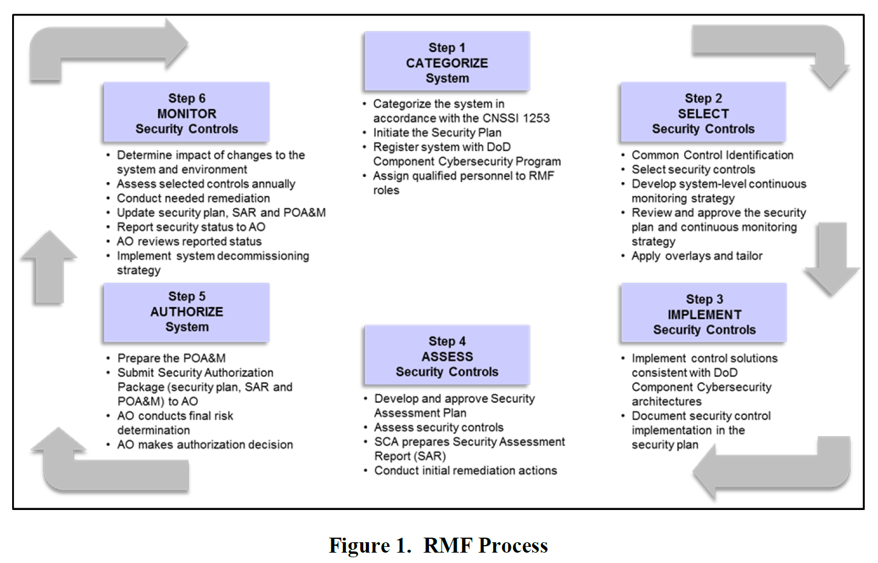
Similarly, we can develop our cyber supply chain risk management framework out of it.
Step 1: Categorize every node on your supply chain.
By doing step 1, the manager can easily divide a huge cyber supply chain into small pieces and find their commons and differences.
Step 2: Select what security measures the project should take.
Identify the main issues that each category will be facing and find the best security control system or measure to handle these issues.
Step 3: Implement security measures
Step 4: Update security measures.
Sometimes the management need to change or update to adapt the mutative situation.
Step 5: Authorize system.
Authorize people who can access the security measures and give insider authority to get and handle the information of the supply chain.
Step 6: Monitor the CSCR
Since the situation is always changing, the CSCR should always be monitored to ensure that if any risk arises, there will be corresponding security measures to deal with it.
    - Impact of Presley & Landry’s, (2016) CSCM risk management framework on PMBOK (2017)
Fig 2 shows a framework for cybersecurity risk management process (Presley & Landry, 2016) and the risk management process form PMBOK (2017)
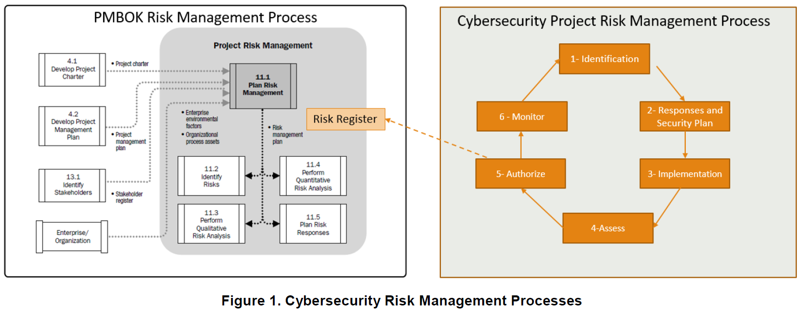
Here is a table to compare these two processes:
Presley & Landry, 2016 | PMBOK (2017)
- Identification | 11.2 Identity risks
- Responses and security plan | 11.1 Plan risk management & 11.5 Plan risk responses
- Implementation
- Assess | 11.3 Perform quantity analysis & 11.4 Perform quality analysis
- Authorize
- Monitor

  - Comparative approaches in presenting cyber supply chain risk management (Australian Cyber Security Centre, (2020) vs Presley & Landry’s, (2016) )
Relevance:
ACSC(2020) article provides a guideline for how to implement a C-SCRM, while Presley & Landry’s(2016) article provides a framework for managing cybersecurity risks in projects.
The Presley & Landry’s one is a bit far from cyber supply chain, though.
Efficiency:
ACSC article has 4 steps of C-SCRM, and Presley & Landry’s has 6 in their process. So the ACSC is a bit more efficient and simpler.
Effectiveness:
They are both effective.
Impact:
C-SCRM model has been cited by many articles, but Presley & Landry’s cybersecurity process has an influence on PMBOK.
Sustainability:
The Presley & Landry’s one has more sustainability since they include update in their model.
Conclusion
Currently, cyber supply chain risks management(C-SCRM) is important to IT or non-IT project. Project managers should always take this into their consideration in order to decrease risks. Meanwhile, it is helpful to build a C-SCRM in your project to assist the project managers manage these risks and find a way out when the cyber supply chain is facing a challenge. These days, the situation is always changing, and a good C-SCRM should always be a good start to protect the whole project from the dangerous world.
Reference(5)
Australian Cyber Security Centre (ACSC), (2020). Cyber Supply Chain Risk Management Practitioner Guide. Retrieved from: https://www.cyber.gov.au/acsc/view-all-content/publications/cyber-supply-chain-risk-management-practitioner-guide
Boyens, J. M. (2020). Key Practices in Cyber Supply Chain Risk Management: Observations from Industry. doi:10.6028/nist.ir.8276-draft
Ghadge, A., Weiß, M., Caldwell, N. D., & Wilding, R. (2019). Managing cyber risk in supply chains: A review and research agenda. Supply Chain Management: An International Journal, 25(2), 223-240. doi:10.1108/scm-10-2018-0357
Heckmann, I., Comes, T., &amp; Nickel, S. (2015). A critical review on supply chain risk – Definition, measure and modeling. Omega, 52, 119-132. doi:10.1016/j.omega.2014.10.004
Peck, H. (2006), “Reconciling supply chain vulnerability, risk and supply chain management”, International Journal of Logistics Research and Applications, Vol. 9 No. 2, pp. 127-142.
Presley, S.S., Landry, J.P., (2016). A Process Framework for Managing Cybersecurity Risks in Projects: Proceedings of the Southern Association for Information Systems Conference, St. Augustine, FL, USA March 18th–19th.
Smith, G. E., Watson, K. J., Baker, W. H. and Pokorski Ii, J. A. (2007), “A critical balance: Collaboration and security in the IT-enabled supply chain”, International Journal of Production Research, Vol. 45 No. 11, pp. 2595-2613.
United States Department of Defense (US DoD) (Sept. 2015), DoD Program Manager’s Guidebook for Integrating the Cybersecurity Risk Management Framework (RMF) into the System Acquisition Lifecycle, Version 1.08, Office of the Secretary of Defense, September 2015. United States Department of Defense, Washington, DC, USA

